Readiness Checklist for GenAI RAG Hackathon.

Step1- Login to Google Colab- <https://colab.research.google.com/>

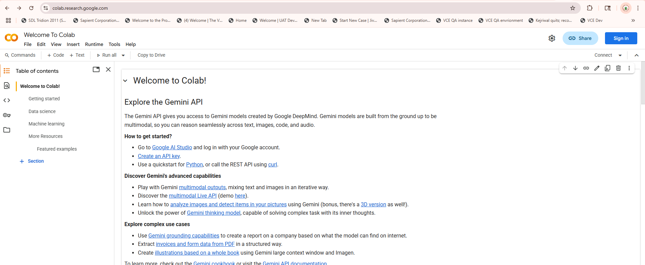

Step2: Sign in with you gmail id click on new notebook

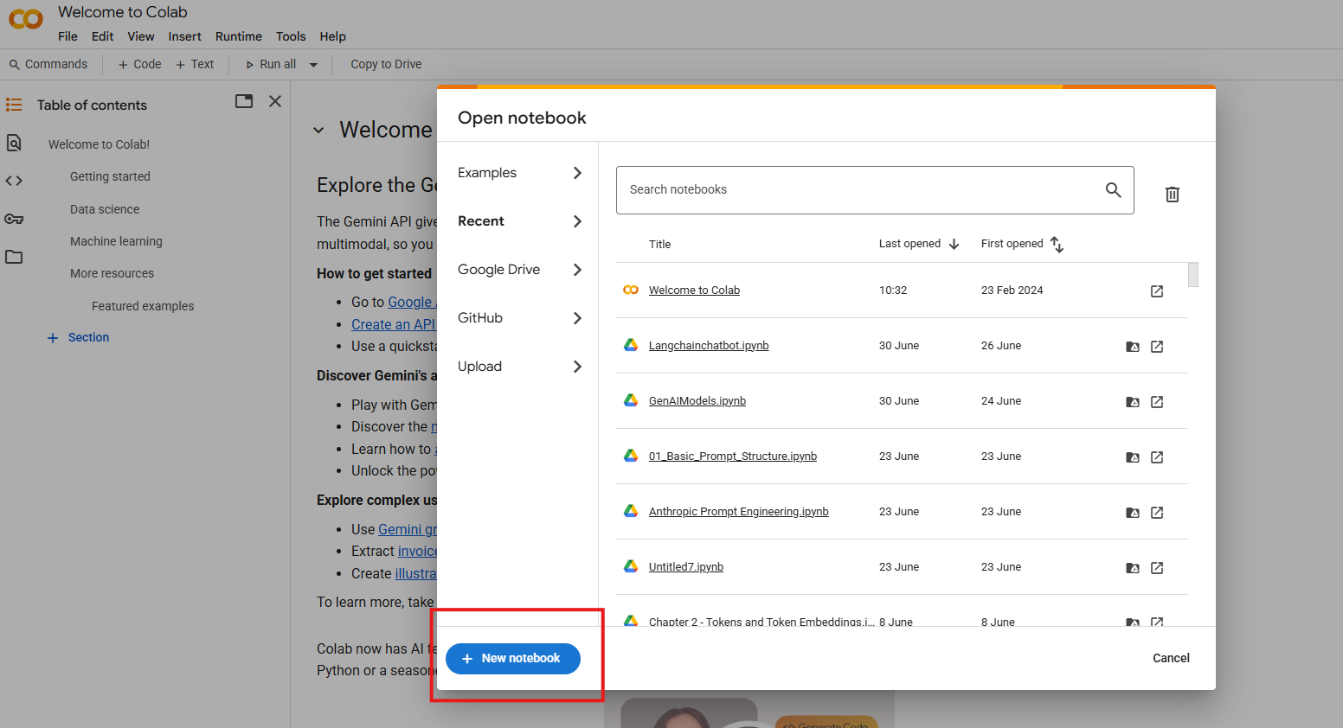

Step3: A new colab notebook would open. Rename it as “GenAI RAG Chatbot”

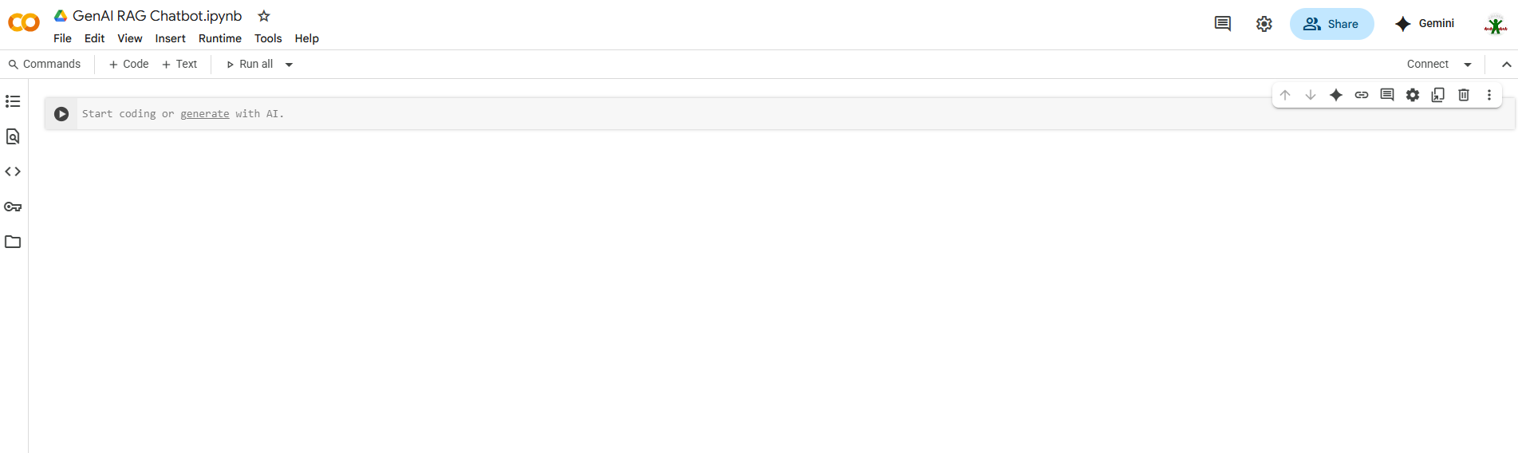

Step4: Get the Gemini API Key

Login to - <https://aistudio.google.com/apikey>

Click on create API Key.

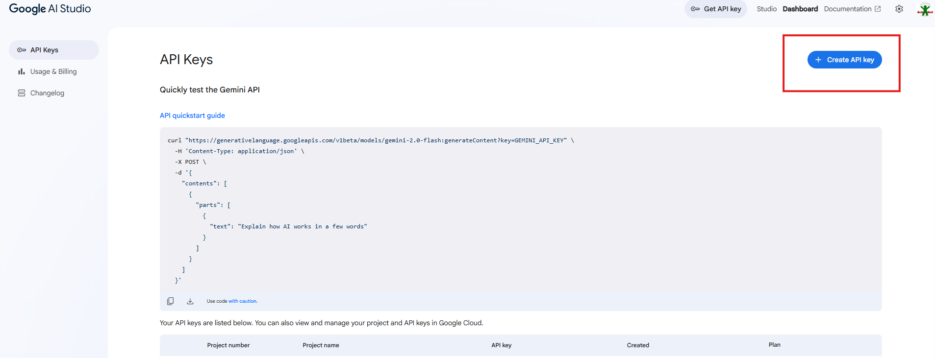

**Copy and Save Google API Key in your system for future reference.**

Step5: Get the OpenAI API Key:

Login to <https://platform.openai.com/api-keys>

Click on create API Key

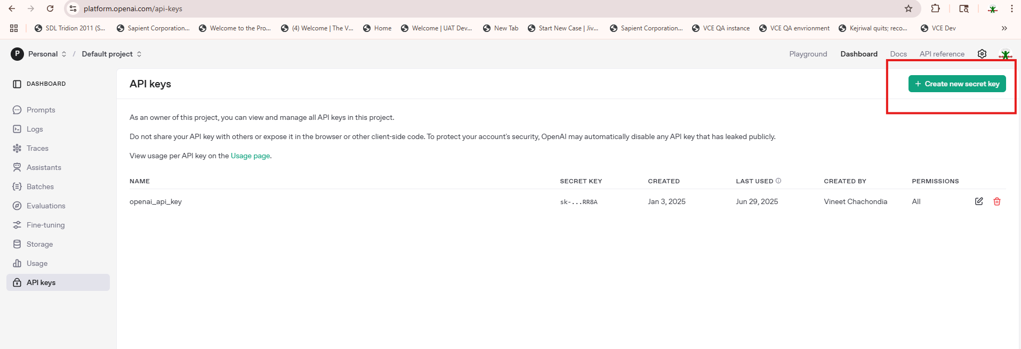

**Copy and Save your OpenAI Key in your system for future reference.**

Step6: Get Groq API Key(Optional):

Login to[**https://console.groq.com/keys**](https://console.groq.com/keys)

Click on create API Key

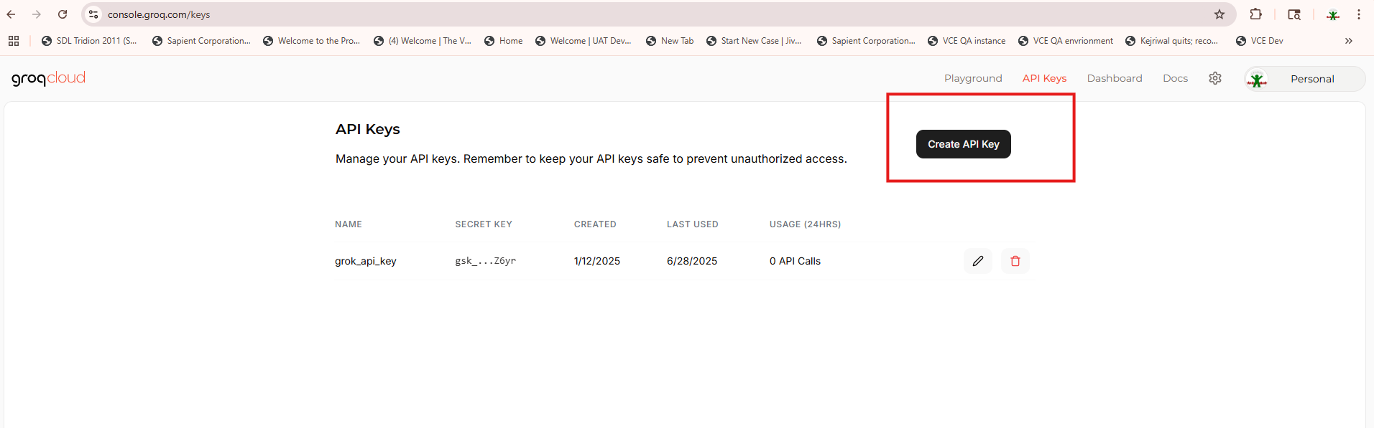

**Copy and Save Groq API key in your system for future reference**

Step7: Update your colab secrets with API Keys

Go to Colab Notebook and click on secrets key(a key symbol) on the left hand side menu

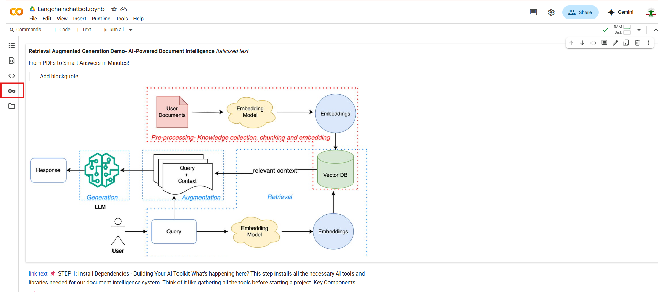

Click on add new secrets

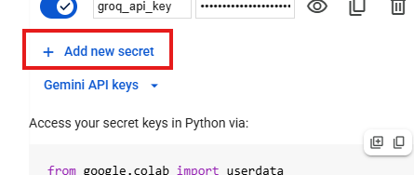

In the name text box put “ GEMINI_API_KEY”(all in caps). In the value put your api key which you have created and save earlier. Enable the notebook access.



Repeat these steps to add the following keys

OPENAI_API_KEY(all in caps)



GROQ_API_KEY(all in caps)



**Awesome, you are all set to use your colab notebook for the hackathon.**

Step8: Download the code file(**RAG Hackathon Langchainchatbot.ipynb**) from this github repo link:

<https://github.com/vin082/Hands-on-LLM/blob/main/RAG%20Hackathon%20Langchainchatbot.ipynb>

Clik on download button on the top right

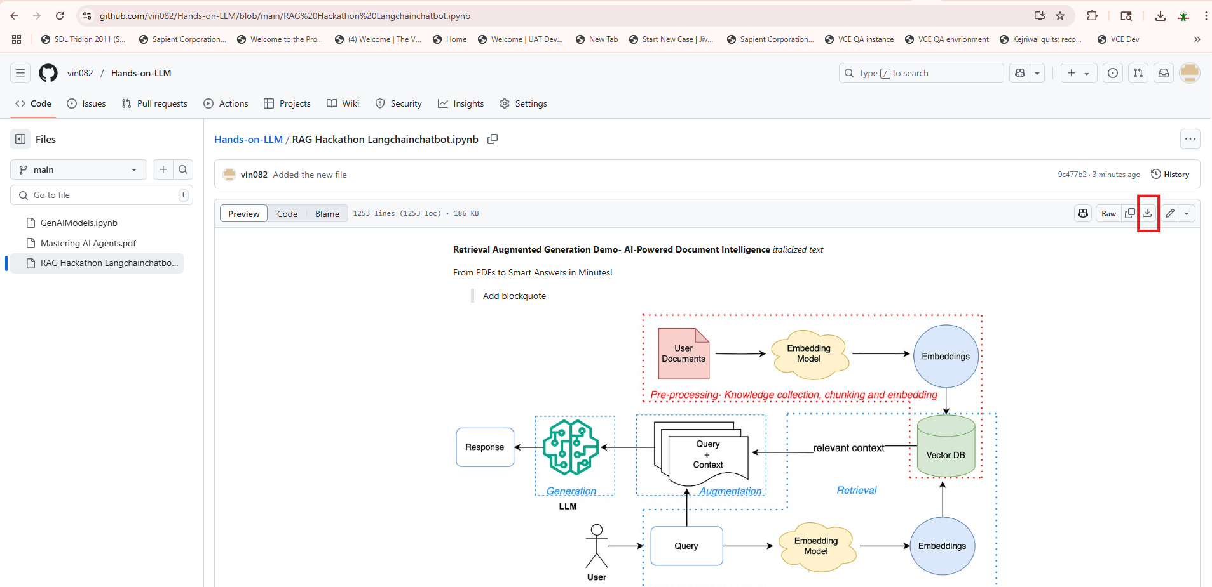

Step9: Upload the downloaded ipynb file in your colab notebook.

Click on File Menu- Upload notebook

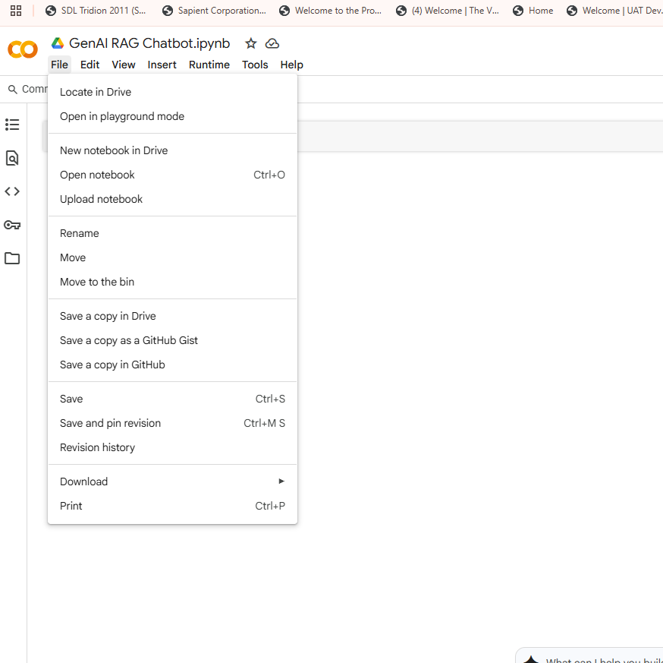

Browse and upload the **RAG Hackathon Langchainchatbot.ipynb** file form your system downloaded from github repo.

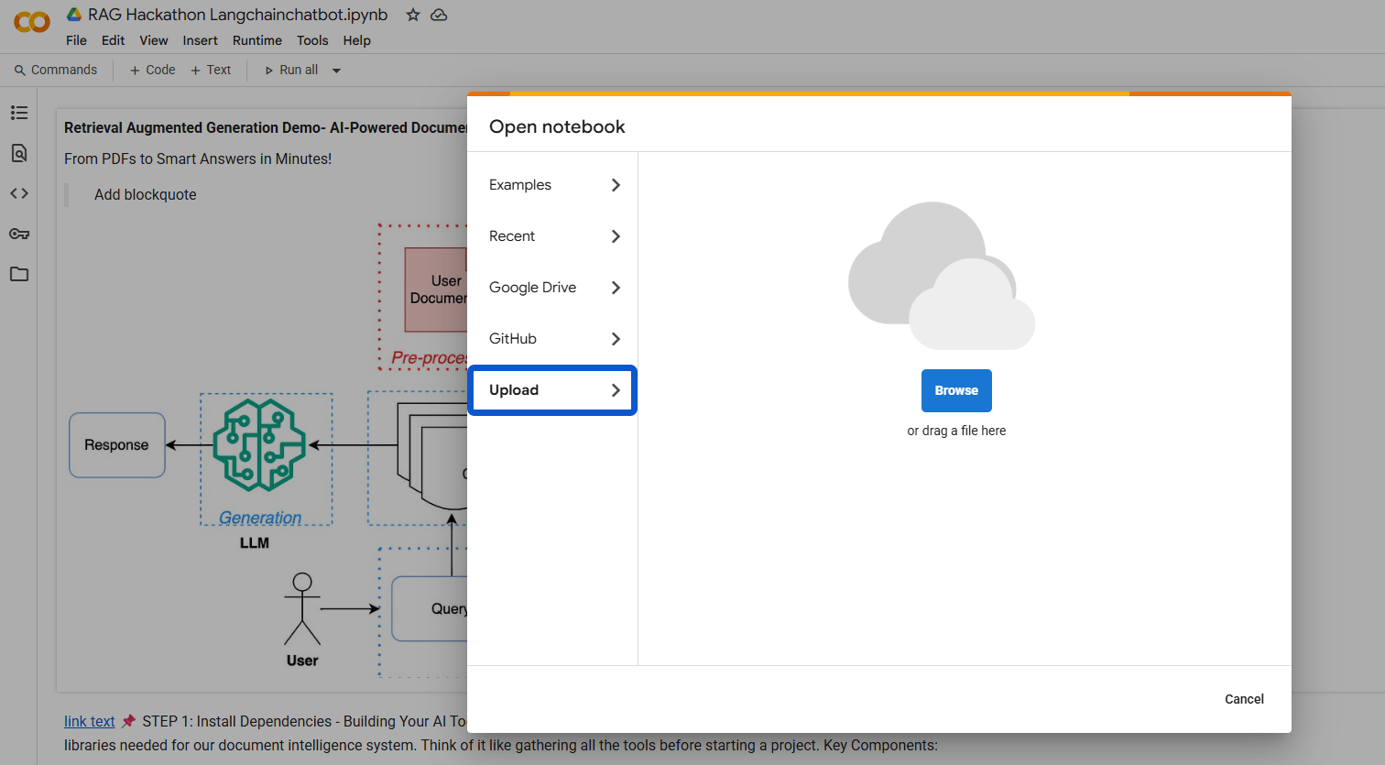

You are all set for the Hackathon. Good luck!!